**ANKARA UNIVERSITY**

**Computer Engineering Department**

**COM4540: Deep Learning (Spring 2023-24)**

**Course Syllabus**

**Instructor:** Dr. İrem Ülkü

**Contact:** [irem.ulku@ankara.edu.tr](mailto:irem.ulku@ankara.edu.tr)

**Reference Textbook:** Deep Learning with Python, François Chollet, Manning; 1st edition, ISBN: 978-1617294433

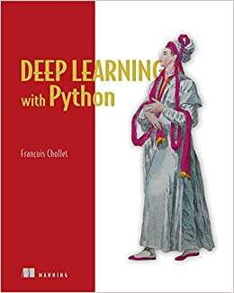

**Lecture Notes:** Will be available on the Moodle weekly.

**Office Hours (OH):** Will be arranged later.

**Course Aim:** This course aims to teach students the basic principles of the deep learning. Students will be able to use Keras to tackle real-world problems especially from computer vision.

**Course Content:** This course includes mathematical building blocks of neural networks, fundamentals of machine learning, deep learning for computer vision, deep learning for text and sequences, advanced deep learning practices and generative deep learning.

**Weekly Schedule:** This is a 3-credit course with 3 lecture hours each week.

**Course Outline:**

|  |  |
| --- | --- |
| WEEK | CONTENTS |
| 1 | What is deep learning? |
| 2 | What is deep learning? |
| 3 | The mathematical building blocks of neural networks |
| 4 | The mathematical building blocks of neural networks |
| 5 | The mathematical building blocks of neural networks |
| 6 | Getting started with neural networks |
| 7 | Getting started with neural networks |
| 8 | Midterm |
| 9 | Fundamentals of machine learning |
| 10 | Deep learning for computer vision |
| 11 | Deep learning for computer vision |
| 12 | Deep learning for text and sequences |
| 13 | Advanced deep learning practices |
| 14 | Generative deep learning |

**Grading:**

|  |  |
| --- | --- |
| **Item** | **Weight** |
| Project Report | %20 |
| Project Presentation | %20 |
| Final | %60 |

**Class Policies:**

* The University Policy on attendance (at least %70 for lectures and at least %80 for laboratories) will be applied.